THE STORY OF JOLLY

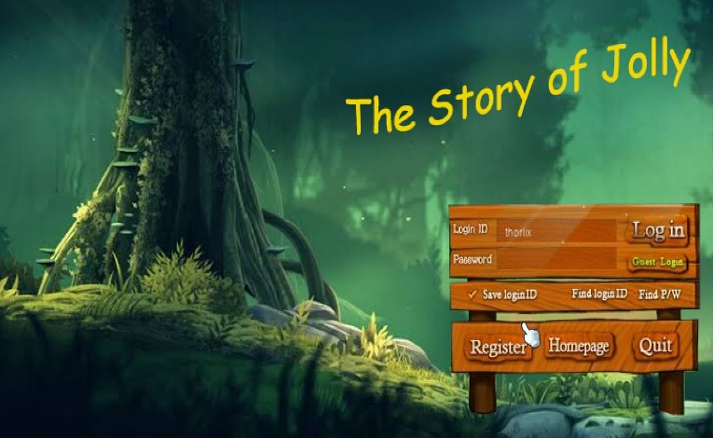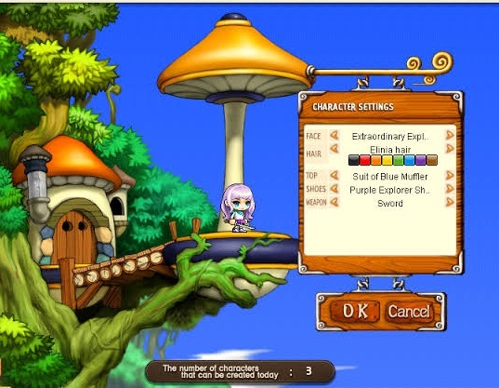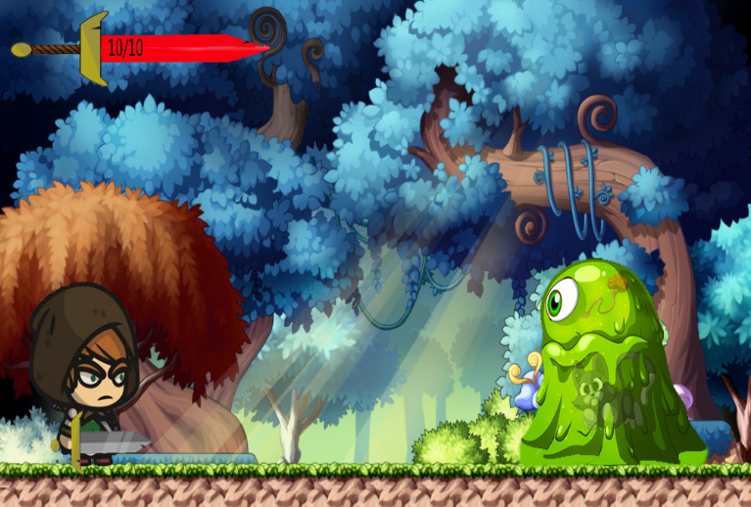

Genre: Platform, Action, Survival, Fighting

Target: ALL

Rating: 12+

Number of Players: 1

Platform: Windows, Apple

Gameplay: It is a 2D game that is more like Mario game with a sword and fight monster to finish the game. You can jump, crouch, walk, sprint, and also climb up ladders in the game that will help you find treasures in the games.

Story: The world has been invaded by slimes and the main character Jolly lost her wife in that invasion and that day he starts to hold a grudge against the slimes and fight against them. He starts to wander around the world and willing to prevent other people from what happened to her wife.